10th Annual UPMA OHIO State Convention


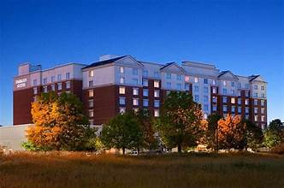

Guide to Exploring Downtown Dublin, Ohio

Where Bridge Park and Historic Dublin are connected by the Dublin Link pedestrian bridge.

From historic architecture to world-class restaurants, Downtown Dublin proves that this is where historic connects with contemporary, traditional blends with trendsetting, and where Irish-approved and world-inspired blend together.
Walk the brick sidewalks on both sides of the Scioto River and find different worlds of architecture, entertainment, taste, shopping, activities, and accommodations are uniquely united.
Downtown Dublin includes Historic Dublin, Bridge Park, The Dublin Link and Riverside Crossing Park.
Situated along the banks of the Scioto River, is where the original village of Dublin stood (1810). Take a self-guided walking tour and among the charming examples of early 19th-century architecture -- where the buildings are now listed on the National Register of Historic Places. Stop by the new Dublin History Museum at 35 S. High Street to see some of the area’s history come to life.
Bridge Park is Dublin's newest development that combines upscale residential living with unique dining, shopping and attractions in Downtown Dublin. The new Riverside Crossing Park lines the Scioto River with green space and easy access to the river while the Dublin Link pedestrian bridge connects Historic Dublin and Bridge Park. (https://ohio.org)
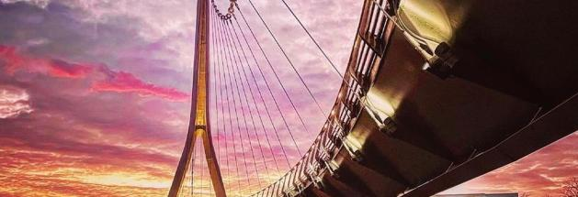

The outdoor Dublin Market returns to Bridge Park on Saturday, May 2! Shoppers can expect the same great local produce, baked goods, flowers and more this year with live entertainment. Head to Bridge Park each Saturday morning from 9 a.m. – 12 p.m. this spring and summer for some family fun.

And more to explore….
The Columbus Zoo and Aquarium are only 15 minutes away from your stay in Dublin, Ohio. The zoo is open year-round but the sights and sounds of the ‘Heart of Africa’ Mudiwa Village region of the park is only open to visitors during warmer months and spans 43 acres featuring zebras, wildebeests, ostriches, gazelles, cheetahs and more. Home to more than 11,000 animals representing nearly 600 species from around the globe. The Zoo complex includes the 22-acre Zoombezi Bay water park and 18-hole Safari Golf Course. The Columbus Zoo and Aquarium also operate the ‘Wilds’, a 10,000-acre conservation and safari park in southeastern Ohio.
Franklin Park Conservatory and Botanical Gardens feature exotic plant collections and displays, seasonal exhibitions, outdoor gardens and a variety of educational programming. All set within the 88-acre Franklin Park. Today, it's famous not only for its plants but also for its James Turrell light installation and its Dale Chihuly glass exhibition.
Just south of downtown Columbus lies German Village Historic and Brewery District, one of the most idyllic neighborhoods in the country. Built by German settlers hundreds of years ago, the area is defined by its brick homes and shops, as well as brick-lined streets. It is a neighborhood with architecture dating from the 1840s-1890s that has been preserved. Local businesses include pastry and coffee shops, unique restaurants, the truly extraordinary 32-room Book Loft, quaint shops and beautiful holiday lights and markets during the winter.
Located downtown on the Scioto Mile, Columbus Center of Science and Industry (COSI ), has combined science learning and fun since 1964 with 300+ hands-on exhibits, Ohio’s largest planetarium, Giant Screen Theater, live shows and more. In 2017, a permanent Dinosaur Gallery exhibition was added, which includes a full-sized cast of a Tyrannosaurus rex, 100-million-year-old fossilized amber, and an eight-foot titanosaur femur cast. COSI also features a special area for the youngest explorers and the country's only high-wire unicycle. Voted best science museum in the nation five times by USA Today’s 10Best awards. (://visitcolumbus.com)

Come join us and have fun exploring the area around the city. This convention is just for you, our valued members, and we look forward to seeing you there!
After the Business Meeting each day, we will have several fun events planned throughout the weekend. We provide free meals with your registration for our members and registered guests. A Convention registration form is included in this newsletter, that includes information for UPMA group hotel accommodations with the group code to use when making your reservations. We are also offering a $300 stipend to any Ohio UPMA member attending all business sessions.

Andrea Leyes
Convention co-chair

