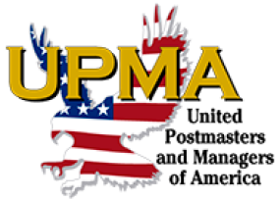

VENDOR REGISTRATION FORM
UPMA Ohio State Convention

The Ohio Chapter UPMA, United Postmasters & Managers of America will be holding their 9th Annual State Convention at Cherry Valley Hotel located at 2299 Cherry Valley Rd SE, Newark OH 43055, from May 1- 4 2025. We invite you to join us as a vendor at our Ohio state convention. Table set up will begin at 6:00 am on Friday, May 2 with the General Business Session starting at 8:00 am. The free participation is one table per vendor. Each vendor will be preassigned their tables.

We welcome any donations to advertise your business, such as gift bag items, door prizes and/or sponsorships of events such as a meal, outing or sponsorship of the Member and Retiree Awards.
If you are interested or need information, please contact Tracy Canby at 937-725-4191.
Thank you for your participation.

We welcome you to enjoy Cherry Valley Hotel with us!

Business Name______________________________Product/Service______________________________

Name_____________________________________________________________________________________

Address___________________________________________________________________________________

City_________________________________________________State__________Zip ____________________

Phone __________________________ Email ___________________________________________________

Number of tables needed ________ Check if electricity is requested _______

Attend # for Friday Lunch $20 ________ Saturday Lunch $20 _________
Attend # for Friday Dinner $30________ Saturday Dinner $30 _________

Total Enclosed $_____________

Please make check or money order payable to Ohio Chapter UPMA.
Mail Registration Form and complete payment to:

Tracy Canby
3574 Fischer Rd
Clarksville OH 45113

Hotel Info: Standard group room rate, May 1-4, 2025, $159 Lawn view, $169 Courtyard view. Call 740-788-1200 or visit online at to reserve your rooms. Call in guests must reference United Postmasters and Managers Ohio to secure the discounted group rate. Check-in is 4:00 pm on arrival and Check-out is at 11:00 am on departure.

