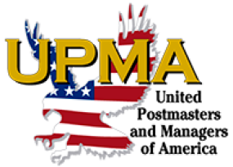

VENDOR REGISTRATION FORM

UPMA Ohio State Convention

The Ohio Chapter UPMA, United Postmasters & Managers of America will be holding their 7th Annual State Convention at Hocking Hills Lodge and Conference Center located at 20020 State Route 664, Logan OH 43138, from June 1-4, 2023. We invite you to join us as a vendor at the convention. Set up will begin at 6:00 am on June 2 with the General session starting at 8:00 am. The fee to participate is $20 per table. Each vendor will be preassigned their tables.

We welcome any donations to advertise your business, such as gift bag items, door prizes and/or sponsorships of events such as a meal, outing or sponsorship of the Member and Retiree Awards. If you are interested, please contact, Patty Schag at 419-565-2685.

Thank you for your participation. Please contact us if you have any questions.

Business Name______________________________Product/Service______________________________

Name_____________________________________________________________________________________

Address___________________________________________________________________________________

City_________________________________________________State__________Zip ____________________

Phone__________________________Email _____________________________________________________

Number of tables needed @ $20 each ________ Check if electricity is requested _______

Friday Lunch $15 ________ Saturday Lunch $15 _________
Friday Dinner $30________ Saturday Dinner $30 _________

Total Enclosed $_____________

Please make check or money order payable to Ohio Chapter UPMA.
Mail Registration Form and complete payment to:

Patty Schag
2089 Pavonia Rd
Mansfield OH 44903

Hotel Info: Basic room rate, June 1, 2023 $184, June 2 – 3, 2023 $202. For other rooms available, please call Hotel for Room Rates. Discounted Room rates are available 3 nights prior to and 3 nights after convention. Call 1-800-282-7275 or visit online at www.HockingHillsParkLodge.com to reserve your rooms. Call in guests must reference UPMA STATE CONVENTION to secure the discounted group rate. UPMA rooms will only be held until April 1, 2023 or till sold out. Check in is 4:00 pm on the arrival day. Check out is at 11:00 am on departure day.

