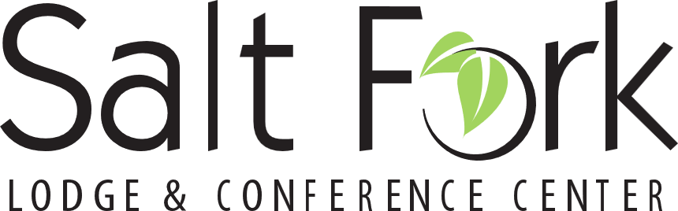
Registration Form
Please complete one form per person attending
May 30 - June 2, 2024

Salt Fork Park Lodge, 14755 Cadiz Rd, Lore City OH 43755
saltforkparklodge.com 1-800-282-7275

First Name _________________________Last Name__________________________________
Postal Position___________________ Office, City State Zip____________________________
Mailing Address________________________________________________________________
Cell Phone________________________ Email_______________________________________

Are you a UPMA Retired Member? YES NO
Are you an Associate Member? YES NO
Are you bringing a Spouse or Guest? YES NO
(Please complete a separate registration form and separate payment for each person)

Will this be your first time attending an Ohio UPMA Convention? YES NO
(*Accommodations information below*)

All persons and guests must be registered to attend any meals and events.
Registration Payment information: $50.00 Check Payable to: Ohio Chapter UPMA

Mail Registration Form and all payments to: Andrea Leyes
994 Hampton Ct
Lebanon OH 45036

Hotel Reservations: To secure the special UPMA discounted group rate, you must reference United Postmasters and Managers UPMA when booking your room. UPMA rooms will be held until April 1, 2024, or until sold out.
Room Rates: May 30, 2024, $119, May 31 - June 2, 2024, $159. Cabins Rate May 30, 2024, $169, 2024, May 31 – June 2, $262. Please call the Hotel to reserve your room, 1-800-282-7275.

*A $400 Stipend and reimbursement of registration fee will be paid to any Ohio UPMA Member attending all business sessions of Ohio Convention at Salt Fork Lodge.
*First Time Attending UPMA member will be paid a $500 stipend and reimbursement of registration fee, for accommodations at Salt Fork Lodge, for attending all Ohio UPMA business sessions May 30 – June 2, 2024.

